**Steps to run the application**

1. Install OTP/Erlang from <https://www.erlang.org/downloads>

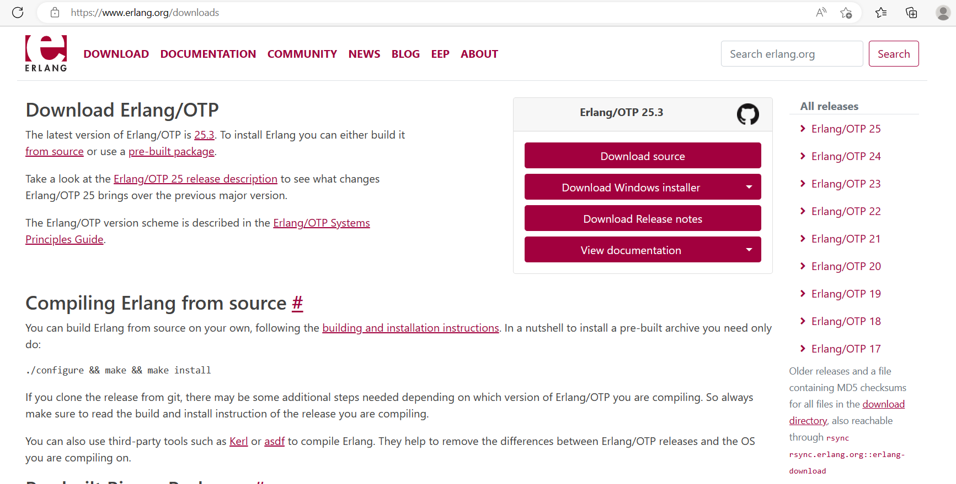

1. Install Rabbit MQ from <https://objects.githubusercontent.com/github-production-release-asset-2e65be/924551>

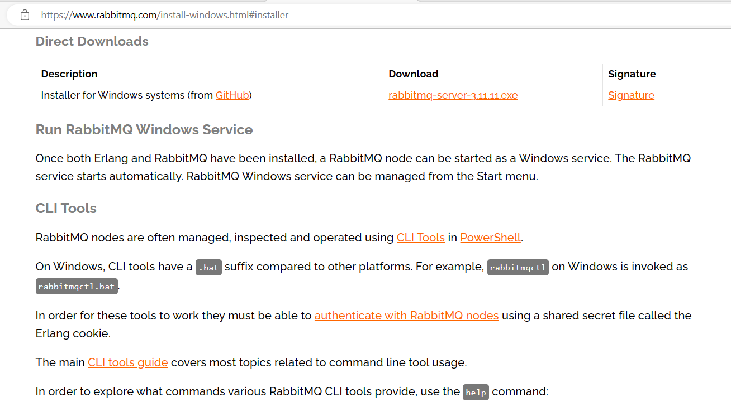

3. RabbitMQ service should be restarted. Open the Cmd window and run the below commands.

cd C:\Program Files\RabbitMQ Server\rabbitmq_server-3.8.7\sbin

rabbitmq-plugins enable rabbitmq_management

net stop RabbitMQ

net start RabbitMQ

Finally open the URL http://localhost:15672/ . The default credentials are guest/guest.

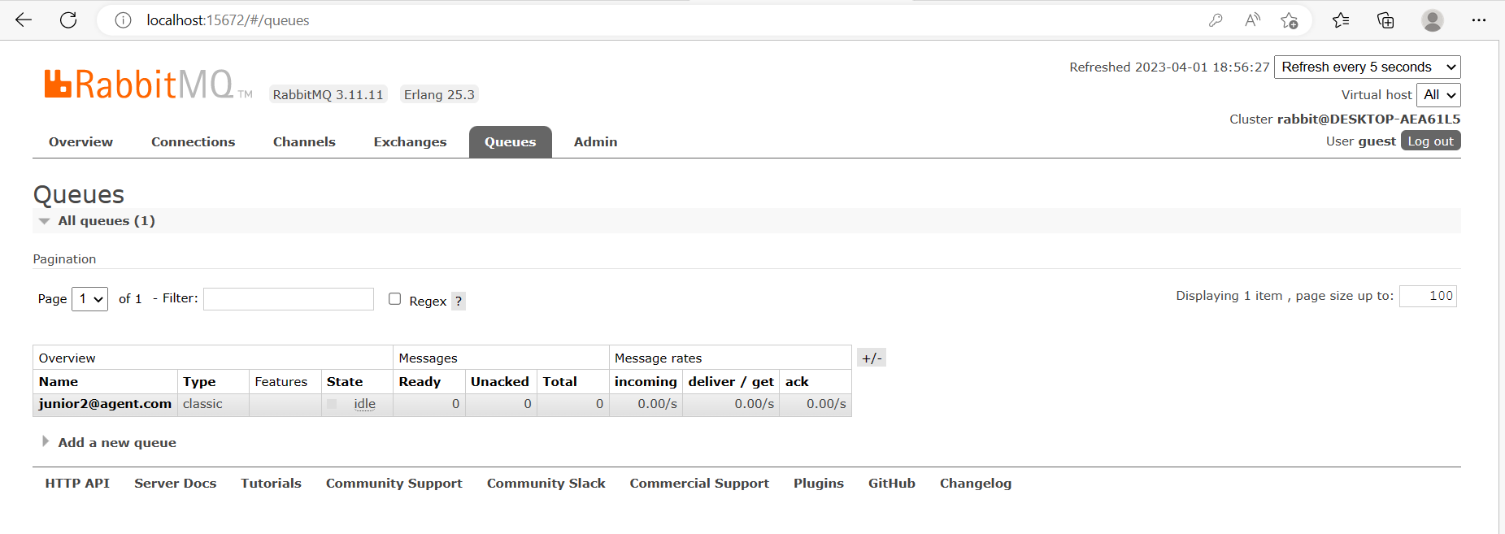

4. Then download the zipped folder for code and SQL server scripts from my GitHub account for which link is given here:

https://github.com/

5. After installation of the above, go to services.msc in windows 10 and find RabbitMQ service. First stop this service and then restart the service.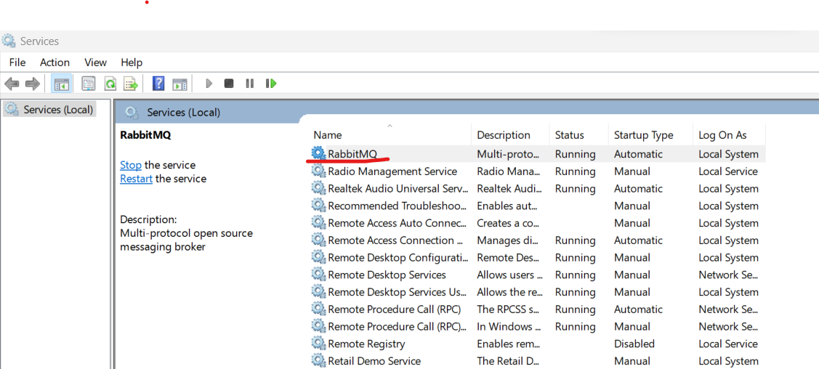

6. Please restore the backup from the .\Backup Db folder ChatAgent.bak

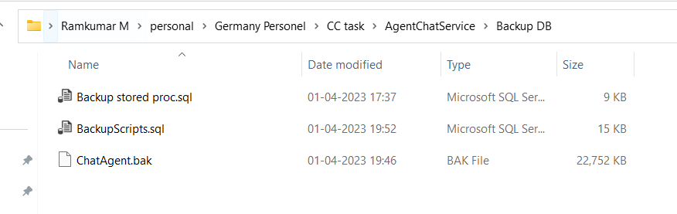

7. Modify the web config,connection string and ChatAgentContext file shown below as per you demo PC

<connectionStrings>

<add name="mycon" connectionString="Data Source=DESKTOP-AEA61L5;Initial Catalog=ChatApplicationDB;Trusted_Connection=True;MultipleActiveResultSets=true;TrustServerCertificate=True"/>

</connectionStrings>

8. IF you find any issues running the application for the first time, please rebuild and run the chat application.

9.Please login with your customer credentials show below

emailid : cust1@cust.com

password: demo (password is same for all customer and support users).

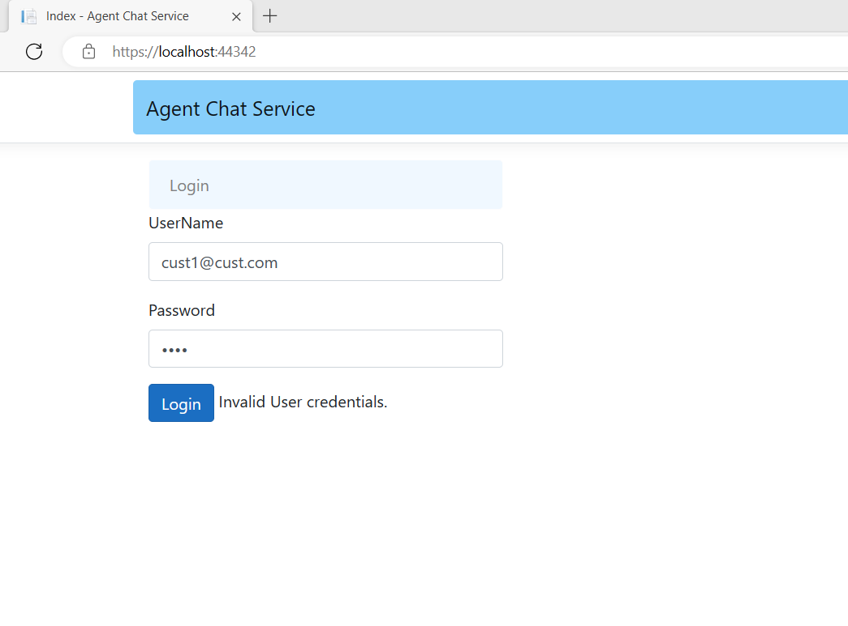

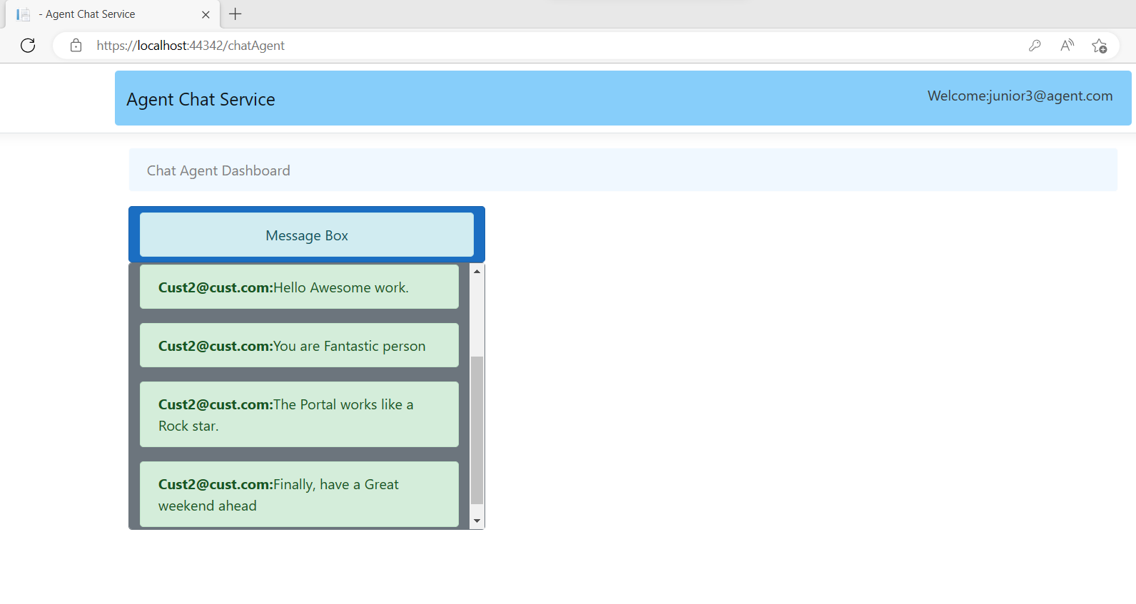

10. Try to login to same URL in other browser as agent with credentials

Emailid: junior1@agent.com

password: demo (password is same for all customer and support users).

